Task :06
Date :01-06-2026

Sub: To Create and Delete the User and Group in AWS Server

1)Frist to connect to the server the instance was running
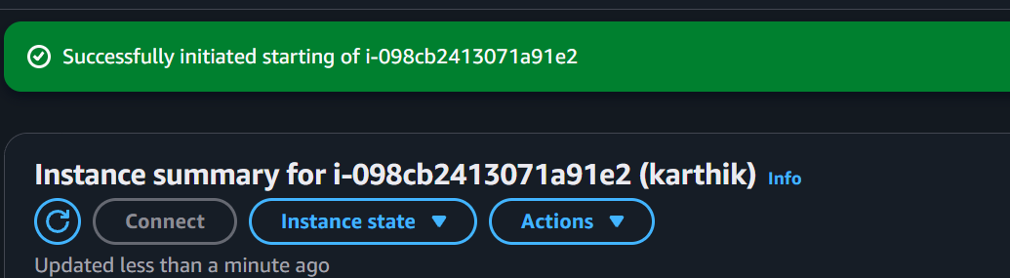

2) click on the connect and click on SSH client and copy the example

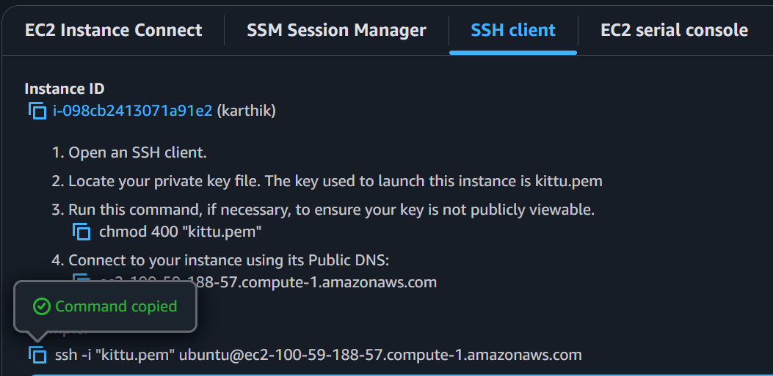

3)Open the terminal and paste the copied one
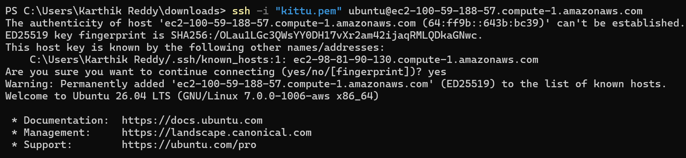
4) Update the package by using the command
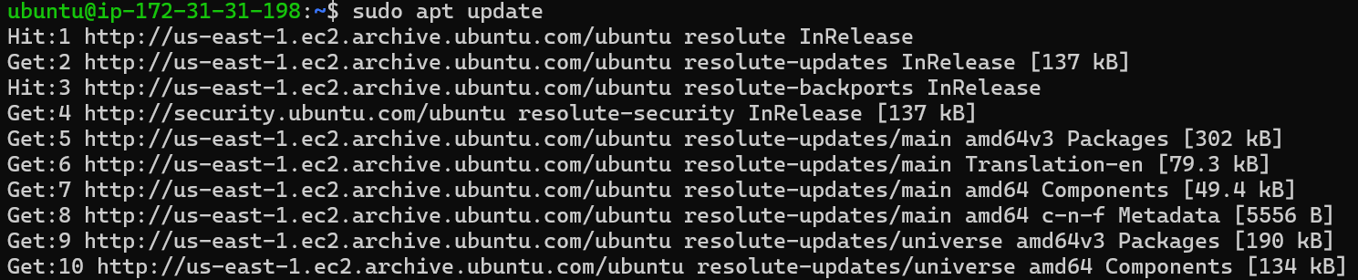

5) To create the user
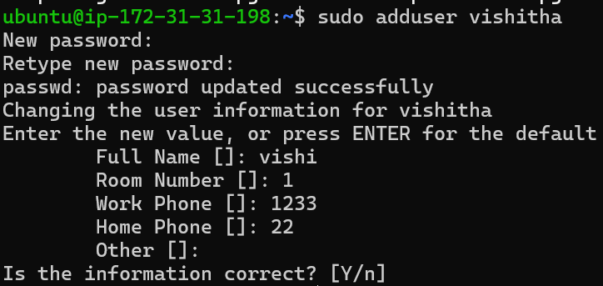

6) To the see or verify the user

7)To create the group
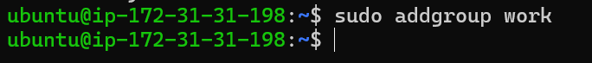

8) To verify the group
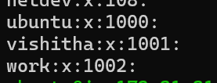

9)Another option to see
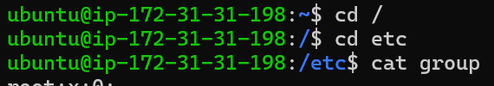

10) To delete the user

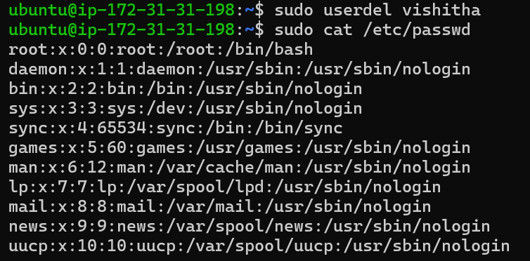
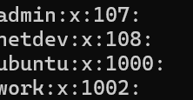

11) To delete the group
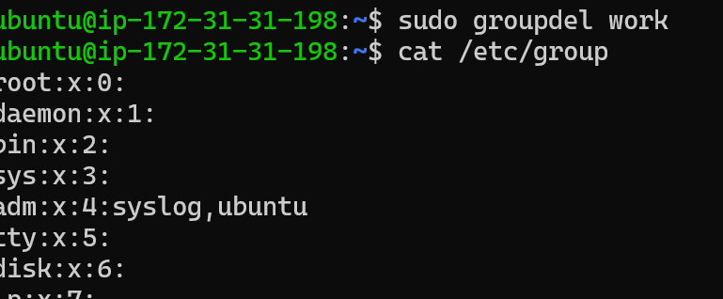
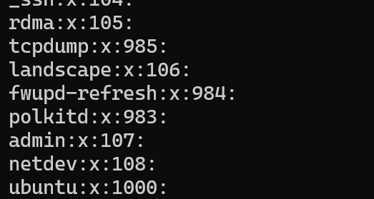

12) After the completed stop the instance
